***Comprehensive digital marketing for Noise***

***Brand study:-***

Introduction to Noise Company

Company Name: Noise

Industry: Consumer Electronics (Wearable Technology & Audio Accessories)

Founded: 2014

Headquarters: Gurugram, India

Founders: Amit Khatri & Gaurav Khatri

Website: [www.gonoise.com](http://www.gonoise.com)

Overview

Noise is one of India’s leading connected lifestyle brands, specializing in smartwatches, wireless earbuds, and audio accessories. The company initially started as a mobile accessories brand but later pivoted to wearable technology, becoming a top player in India’s smartwatch and hearable market.

Key Achievements

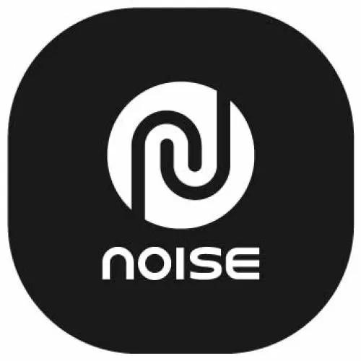India’s No.1 Smartwatch Brand (as per IDC, 2021 & 2022)

Top 5 Global Smartwatch Brand in 2022

Ranked among India’s top D2C brands

Product Categories

1. Smartwatches – Fitness tracking, health monitoring (SpO2, heart rate), and notifications
2. Wireless Earbuds (TWS) – Affordable and high-quality sound experience
3. Accessories – Smart glasses, wireless chargers, and gaming audio products

Market Positioning

Affordable Premium: Offers premium features at budget-friendly prices

Tech-Driven: Focus on AI, health tracking, and innovation

Target Audience: Gen Z, millennials, fitness enthusiasts, and tech-savvy users

Recent Developments

Expanding offline retail presence in tier 2 and tier 3 cities

Supporting ‘Make in India’ by localizing production

Collaborations with Virat Kohli, Rishabh Pant, and Taapsee Pannu as brand ambassadors

Would you like insights on their marketing strategy or future growth plans?

Noise is an Indian consumer electronics brand specializing in smart wearables and audio devices. Founded by brothers Amit and Gaurav Khatri, the company has rapidly become a prominent player in India's tech industry. Noise offers a diverse range of products, including smartwatches, wireless earbuds, neckband earphones, and wireless headphones.

The brand's product lineup features smartwatches with various designs, such as AMOLED displays and metallic or leather round dials, catering to different user preferences. Their audio accessories include best-selling wireless earbuds, active noise cancellation (ANC) earbuds, and neckbands, all designed to provide high-quality sound experiences.

Noise has established itself as India's number one smartwatch brand, driven by its mission to democratize the connected lifestyle for Indians. The company's commitment to innovation and quality has positioned it among the top five brands in India's Bluetooth-connected earphones market as of June 2020.

In December 2023, Noise secured a $10 million Series A funding round, with participation from investors including Bose. This investment aims to further enhance their product offerings and expand their market presence.

Noise's dedication to delivering affordable, high-quality smart wearables and audio devices has made it a trusted name among Indian consumers seeking reliable and stylish technology solutions.

Competitor Analysis:-

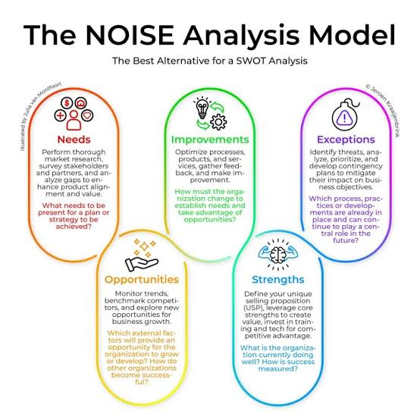Noise, an Indian aspirational connected lifestyle brand established in 2018, specializes in technology accessories such as smartwatches and true wireless stereo (TWS) earbuds.

**Primary Competitors**

Noise operates in a competitive market alongside several notable brands:

* **boAt**: Founded in 2014 and headquartered in Mumbai, boAt is a significant competitor in the electronic equipment sector. The company offers a range of audio products and has achieved substantial revenue, reportedly generating 222% of Noise's earnings.
* **Fire-Boltt**: Established in 2016 in Mumbai, Fire-Boltt operates within the gyms and fitness industry, providing products that align with Noise's offerings. Although specific employee numbers are not disclosed, Fire-Boltt is recognized as a top competitor.

**Other Competitors**

Additional competitors in the wearable and audio accessories market include:

* **Caspex Corporation Pvt. Ltd.**: Specializes in noise management solutions across various sectors, offering sound control systems and engineering interventions.
* **Mecord Systems & Services Pvt. Ltd.**: Provides noise control systems and acoustic engineering services, catering to industries such as manufacturing and infrastructure.
* **Fabheads Automation Pvt. Ltd.**: Focuses on automation-driven solutions for advanced composite manufacturing, serving industries like aerospace and automotive.

**Market Position**

Noise has established itself as a leading brand in India's smartwatch and hearable categories. As per IDC, Noise led the wearable watch market with a 27.0% share in 2021, based on shipments. The company's commitment to customer-centricity and understanding consumer demands has contributed to its significant market presence.

In summary, Noise competes with several prominent brands in the wearable technology and audio accessories market, notably boAt and Fire-Boltt, and continues to maintain a strong position through its focus on consumer needs and innovative product offerings.

### **Buyer Persona of Noise Company**

Noise primarily targets young, tech-savvy consumers who are health-conscious, fashion-forward, and budget-conscious. Their products cater to individuals looking for affordable yet feature-rich smartwatches, earbuds, and wearables. Below are the key buyer personas for Noise:

### **1. The Fitness Enthusiast**

* **Age Group**: 18-35 years
* **Gender**: All genders
* **Occupation**: Students, young professionals, fitness trainers
* **Income Level**: Middle-class to upper-middle-class (₹25,000 - ₹80,000 monthly income)
* **Pain Points**:
  + Wants an affordable alternative to premium smartwatches
  + Needs accurate health tracking (heart rate, SpO2, steps, sleep)
  + Prefers long battery life and water-resistant features
* **Buying Motivation**:
  + Tracks fitness progress and workouts
  + Integrates with fitness apps (Google Fit, Apple Health)
  + Stylish design for gym and daily wear
* **Preferred Channels**: Amazon, Flipkart, Myntra, Noise’s website

### **2. The Young Professional & Student**

* **Age Group**: 18-30 years
* **Gender**: All genders
* **Occupation**: College students, early-career professionals
* **Income Level**: ₹20,000 - ₹50,000 monthly income
* **Pain Points**:
  + Wants stylish, multifunctional accessories at an affordable price
  + Needs long battery life and easy connectivity with a smartphone
  + Prefers a seamless calling/music experience for work and travel
* **Buying Motivation**:
  + Smartwatches for daily use, notifications, and work-life management
  + Wireless earbuds for work calls, gaming, and entertainment
  + Affordable premium design for a stylish look
* **Preferred Channels**: Social media (Instagram, YouTube), online marketplaces

### **3. The Tech-Savvy Trendsetter**

* **Age Group**: 16-28 years
* **Gender**: Mostly Gen Z and young millennials
* **Occupation**: Social media influencers, content creators, digital marketers
* **Income Level**: ₹30,000 - ₹75,000 monthly income
* **Pain Points**:
  + Wants feature-packed wearables with trendy designs
  + Prefers fast-charging devices with smart assistant support
  + Needs affordable, high-quality alternatives to premium brands
* **Buying Motivation**:
  + Follows celebrity and influencer recommendations
  + Prefers tech with social credibility and unique features
  + Enjoys experimenting with customizable watch faces and accessories
* **Preferred Channels**: Instagram, YouTube, Flipkart, Noise’s official store

### **4. The Budget-Conscious Consumer**

* **Age Group**: 18-40 years
* **Gender**: All genders
* **Occupation**: Entry-level employees, students, homemakers
* **Income Level**: ₹15,000 - ₹40,000 monthly income
* **Pain Points**:
  + Needs a smartwatch for health tracking but can’t afford premium brands
  + Prefers reliable, budget-friendly earbuds for calls and music
  + Seeks discounts and value-for-money deals
* **Buying Motivation**:
  + Competitive pricing compared to Apple, Samsung, or Garmin
  + Strong battery life and good warranty support
  + Looks for festive sales and bundle deals
* **Preferred Channels**: Online marketplaces, direct brand website, offline retail stores

### **5. The Gift Buyer**

* **Age Group**: 25-50 years
* **Gender**: All genders
* **Occupation**: Working professionals, homemakers
* **Income Level**: ₹40,000 - ₹1,00,000+ monthly income
* **Pain Points**:
  + Looking for an affordable yet premium-looking gift
  + Unsure which tech gadget to choose for loved ones
* **Buying Motivation**:
  + Smartwatches and earbuds as trendy, practical gifts
  + Value-for-money with good reviews and recommendations
* **Preferred Channels**: Amazon, Flipkart, brand website, Croma, Reliance Digital

**SEO&keyword research:**

An SEO audit of “noise” would involve analyzing the website’s content, technical aspects, and user experience to identify areas for improvement in search engine rankings and overall performance related to the keyword “noise”.

Here's a breakdown of what such an audit would details given below

1.Keyword research and analysis

Identify relevant keywords:

Conduct thorough research to determine the most relevant keywords and phrases related to “noise” that users are searching for.

Analyze search intent:

Understand the different types of searches users make when looking for information about “noise” (e.g., noise reduction, noise pollution, types of noise).

Competitor analysis:

Identify and analyze the websites that rank well for relevant keywords related to “noise” to understand their strategies and content.

2.on page SEO Audit:

Content analysis:

Evaluate the quality, relevance, and optimization of content related to “noise” on the website.

Keyword optimization:

Ensure that relevant keywords are strategically used in page titles, meta descriptions, headings, and body text.

Image optimization:

Optimize images with relevant alt text and file names to improve SEO and accessibility.

Internal linking:

Analyze the internal linking structure to ensure that relevant pages are linked to each other.

User experience (UX) optimization:

Ensure the website is user-friendly, with clear navigation, fast loading times, and a mobile-friendly design.

3.Technical SEO Audit:

Website speed: Assess website loading speed and identify areas for improvement.

Mobile-friendliness: Ensure the website is responsive and optimized for mobile devices.

Broken links: Identify and fix any broken links that may be negatively impacting the user experience.

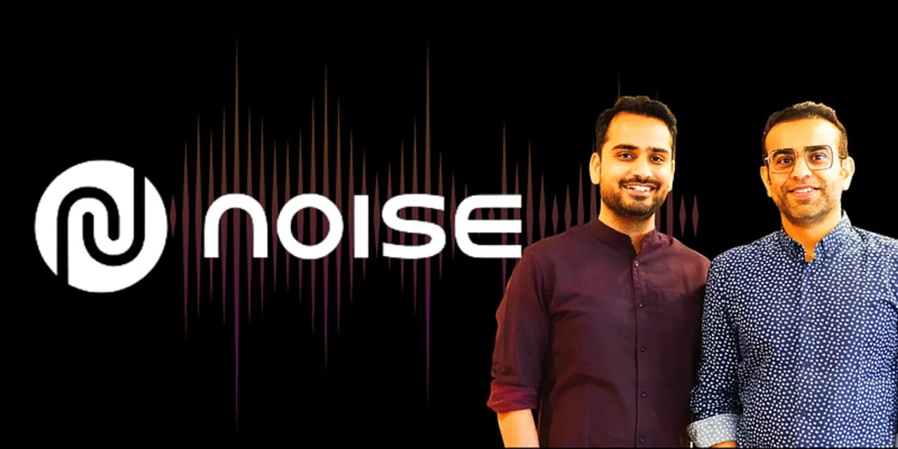Sitemap and robots.txt: Review the sitemap and robots.txt files to ensure that search engines can crawl and index the website effectively.

Duplicate content: Identify and address any instances of duplicate content that may be diluting the website’s SEO efforts.

Schema markup: Implement schema markup to help search engines better understand the context of the website’s content.

. Off-Page SEO Audit:

Backlink profile:

Analyze the website’s backlink profile to identify the quality and relevance of backlinks.

Social media presence:

Assess the website’s social media presence and engagement to identify opportunities for promoting content and building brand awareness.

Local SEO:

If applicable, optimize the website for local search results by ensuring that the business is listed in relevant directories and has accurate location information.

4.conduct research:

Content relevance:

Ensure that the content on the website is relevant to the target audience and search intent.

Content quality:

Evaluate the quality of the content, ensuring that it is informative, engaging, and well-written.

Content freshness:

Regularly update and refresh the content to ensure that it is up-to-date and relevant.

Content gaps:

Identify any content gaps or areas where the website is missing relevant **information**

**Keyword research**

**To conduct keyword research for "Noise Company," focus on terms related to their product categories (smartwatches, headphones) and their target audience's search intent, using tools like Google Keyword Planner and analyzing competitor keywords.**

**Here's a more detailed breakdown:**

**1. Identify Product Categories and Target Audience:**

**Noise Company Products: Smartwatches, headphones, earbuds**

**Target Audience: Consider demographics (age, gender, location), interests (fitness, music, tech), and purchasing behaviors.**

**2. Brainstorm Keywords:**

**General Keywords:**

**"Smartwatch"**

**"Noise Smartwatch"**

**"Noise Headphones"**

**"Noise Earbuds"**

**"Fitness Tracker"**

**"Wireless Headphones"**

**"Noise Cancelling Headphones"**

**Long-Tail Keywords:**

**"Best Noise Smartwatch for [Specific Activity]"**

**"Noise Headphones with [Specific Feature]"**

**"Noise Earbuds for [Specific Purpose]"**

**"Noise Smartwatch Price in [Location]"**

**Competitor Keywords: Analyze keywords used by competitors (e.g., Fitbit, Samsung, Apple).**

**3. Keyword Research Tools:**

**Google Keyword Planner:**

**A free tool within Google Ads that provides insights into search volume, competition, and related keywords.**

**SEMrush:**

**A paid tool with comprehensive keyword research features, including keyword difficulty, search volume, and competitor analysis.**

**Ahrefs:**

**Another paid tool known for its SEO and keyword research capabilities.**

**Moz Keyword Explorer:**

**A paid tool that offers keyword difficulty, search volume, and related keywords.**

**4. Analyze Keywords:**

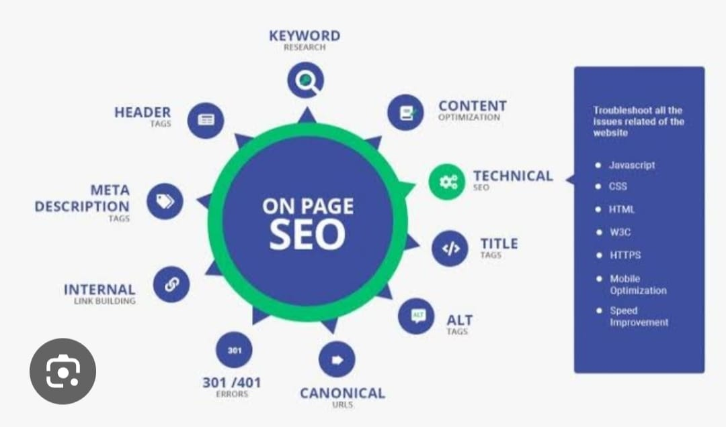**Search Volume: Identify keywords with high monthly search volume.**

**Keyword Difficulty: Assess the difficulty of ranking for specific keywords.**

**Relevance: Ensure keywords are relevant to Noise Company's products and target audience.**

**Search Intent: Understand the user's intent behind their search query (e.g., informational, navigational, transactional).**

**5. Implement Keyword Strategy:**

**Optimize Website Content: Incorporate relevant keywords into website pages, product descriptions, and blog posts.**

**Create Targeted Ads: Use keywords in Google Ads campaigns to reach the right audience.**

**On page optimization**

On-page optimization, or on-site SEO, focuses on optimizing elements within a webpage to improve its search engine ranking and user experience, including content, keywords, title tags, and meta descriptions

Definition:

**On-page SEO is the practice of optimizing a webpage to rank higher in search engine results pages (SERPs) and to get more relevant traffic.**

**Goal:**

**The aim is to improve the quality of a webpage so that it will be ranked higher by search engines.**

**Control:**

**On-page SEO is entirely within your control, focusing on the content and HTML source code of a page.**

**Contrast with Off-Page SEO:**

**On-page SEO differs from off-page SEO, which focuses on SEO measures outside of your own website, such as incoming links.**

**Key Elements of On-Page SEO:**

**Keyword Research: Identify the keywords and phrases your target audience uses when searching for information related to your content.**

**High-Quality Content: Create informative, engaging, and relevant content that provides value to users.**

**Content Structure: Use headings (H1, H2, H3, etc.), subheadings, bullet points, and other formatting elements to make your content easy to read and scan.**

**Page Structure:**

**Title Tags: Write compelling and accurate title tags that include your target keywords.**

**Meta Descriptions: Craft concise and engaging meta descriptions that entice users to click on your search result.**

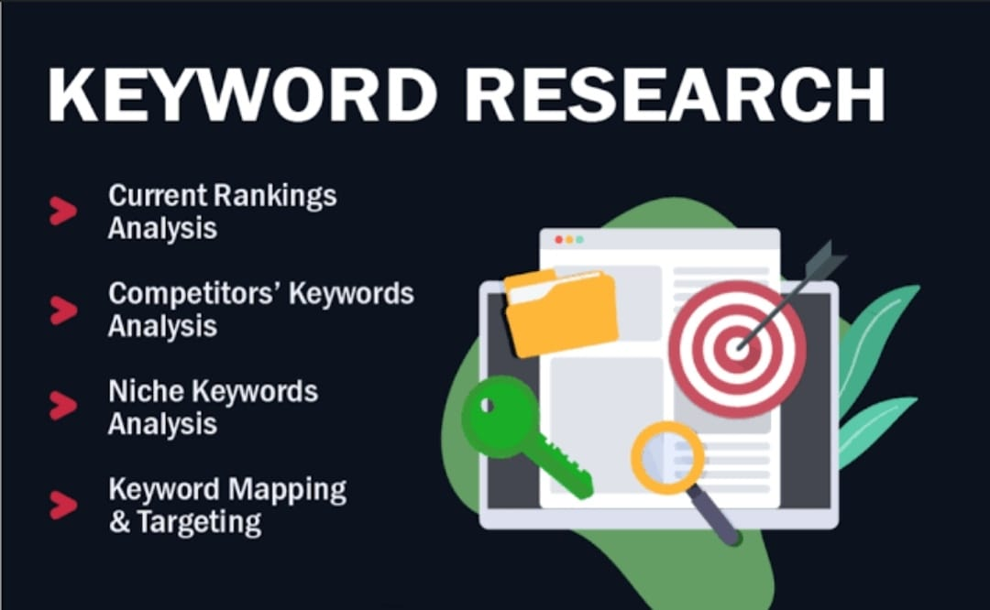**URLs: Use clear and concise URLs that include your target keywords.**

**Images:**

**Optimized Images: Use high-quality images that are optimized for the web.**

**Alt Text: Provide descriptive alt text for all images to help search engines understand the content.**

**Internal Linking:**

**Link to Relevant Pages: Link to other relevant pages on your website to help search engines understand the structure of your site and improve user navigation.**

**User Experience:**

**Mobile-Friendliness: Ensure your website is mobile-friendly and easy to navigate on all devices.**

**Page Speed: Optimize your website’s page speed to ensure a fast and smooth user experience.**

**Site Structure: Ensure your website is well-organized and easy to navigate.**

**Content idea generation and strategy -**

**Let’s brainstorm content ideas and strategies for the “Noise” brand, focusing on its core offerings (smartwatches, earbuds, speakers, etc.) and target audience (primarily young, tech-savvy individuals).**

**I. Core Brand Pillars & Messaging:**

**\* Youthful Energy & Style: Noise is about vibrant living, expressing individuality, and staying ahead of trends.**

**\* Accessible Technology: High-quality tech doesn’t have to break the bank. Noise offers value-driven products.**

**\* Active Lifestyle & Wellness: Promoting fitness, health tracking, and an on-the-go lifestyle.**

**\* Connectivity & Entertainment: Seamlessly integrating technology into daily life for communication and enjoyment.**

**II. Content Idea Generation:**

**A. Smartwatches:**

**\* “Day in the Life” Videos:**

**\* Showcase how Noise smartwatches integrate into various lifestyles (student, professional, athlete).**

**\* Highlight specific features like fitness tracking, notifications, and watch faces.**

**\* Fitness Challenges & Tutorials:**

**\* Create engaging fitness challenges using the smartwatch’s tracking capabilities.**

**\* Provide tutorials on how to maximize fitness features (heart rate monitoring, sleep tracking).**

**\* Partner with fitness influencers.**

**\* Style & Customization Content:**

**\* Showcase different watch faces and strap options to match personal style.**

**\* Create “Outfit of the Day” (OOTD) posts featuring the smartwatch.**

**\* Comparison Videos/Articles:**

**\* Showcase how Noise watches compare to other products in the market, emphasizing value.**

**\* Highlight key differences between models.**

**\* “Tech Tips & Tricks” Shorts:**

**\* Quick, digestible videos showing users how to use specific smartwatch features.**

**\* Addressing common user questions.**

**B. Earbuds:**

**\* “Sound Experience” Content:**

**\* Create immersive audio experiences through visually appealing videos.**

**\* Highlight noise cancellation and sound quality.**

**\* Showcase different music genres.**

**\* “Travel & Commute” Content:**

**\* Demonstrate how Noise earbuds enhance travel experiences.**

**\* Focus on noise cancellation in noisy environments.**

**\* “Gaming & Entertainment” Content:**

**\* Showcase the earbuds’ low latency and audio quality for gaming.**

**\* Partner with gaming influencers.**

**\* “Workout Playlist” Content:**

**\* Curate and share workout playlists optimized for Noise earbuds.**

**\* Highlight the earbuds’ secure fit and sweat resistance.**

**\* “Unboxing & Review” Videos:**

**\* Send products to tech reviewers and influencers.**

**\* Create visually appealing unboxing videos.**

**C. Speakers:**

**\* “Party & Social Gathering” Content:**

**\* Showcase the speakers’ portability and sound quality in social settings.**

**\* Create visually engaging videos of parties and gatherings.**

**\* “Outdoor Adventure” Content:**

**\* Demonstrate the speakers’ durability and water resistance in outdoor environments.**

**\* Highlight their portability for hikes, picnics, and beach trips.**

**\* “Home Entertainment” Content:**

**\* Showcase the speakers’ ability to enhance home entertainment experiences.**

**\* Create videos of movie nights and listening sessions.**

**\* “Sound Demonstrations”:**

**\* Showcase the range and quality of the sound the speakers produce.**

**\* Use visually appealing methods to showcase the audio.**

**D. General Brand Content:**

**\* User-Generated Content (UGC):**

**\* Encourage users to share their experiences with Noise products.**

**\* Run contests and giveaways to generate UGC.**

**\* Behind-the-Scenes Content:**

**\* Showcase the design and manufacturing process of Noise products.**

**\* Highlight the team behind the brand.**

**\* Collaborations & Partnerships:**

**\* Partner with influencers, musicians, and athletes to create engaging content.**

**\* Collaborate with other brands that align with Noise’s values.**

**\* Interactive Content:**

**\* Create quizzes, polls, and AR filters to engage the audience.**

**\* Host live Q&A sessions.**

**\* Seasonal Campaigns:**

**\* Create content that aligns with holidays, festivals, and seasonal trends.**

**\* Run promotions and discounts during key shopping periods.**

**\* Educational Content:**

**\* Explain the technology behind Noise products in a simple and engaging way.**

**\* Provide tips on how to care for and maintain devices.**

**III. Content Strategy:**

**\* Platform-Specific Content:**

**\* Tailor content to each platform (Instagram, YouTube, TikTok, etc.).**

**\* Use relevant hashtags and trends.**

**\* Consistent Posting Schedule:**

**\* Establish a regular posting schedule to maintain audience engagement.**

**\* Data-Driven Approach:**

**\* Track content performance and adjust strategy accordingly.**

**\* Use analytics to identify what resonates with the audience.**

**\* Community Engagement:**

**\* Respond to comments and messages promptly.**

**\* Foster a sense of community around the Noise brand.**

**\* Influencer Marketing:**

**\* Identify and collaborate with influencers that align with the brand’s image and target audience.**

**\* Focus on micro and nano influencers for better engagement.**

**\* Short form video:**

**\* Focus on creating short form video content for platforms like Instagram reels, youtube shorts, and tiktok.**

**\* This is the most effective way to reach the target demographic.**

**\* SEO Optimization:**

**\* Optimize website content and YouTube videos for relevant keywords.**

**\* Drive organic traffic to Noise’s online platforms.**

**Marketing Strategy:-**

**A marketing strategy for Noise, the Indian consumer electronics brand known for smartwatches, wireless earbuds, and accessories, should focus on brand positioning, digital presence, and customer engagement. Here’s a structured approach:**

* + 1. **Brand Positioning & Differentiation**

**Youth-Centric & Affordable Innovation: Highlight affordability with premium features.**

**Indian Identity: Leverage the “Made for India” narrative.**

**Health & Fitness Lifestyle: Position Noise smartwatches as essential fitness and wellness companions.**

* + 1. **Target Audience**

**Tech-Savvy Millennials & Gen Z (18-35 years)**

**Fitness Enthusiasts**

**Urban Professionals & Students**

* + 1. **Digital Marketing Strategy**
       1. **Social Media Marketing**

**Instagram & Facebook: Influencer collaborations, user-generated content, fitness challenges.**

**YouTube & Reels: Short, engaging product demo videos, unboxings, and testimonials.**

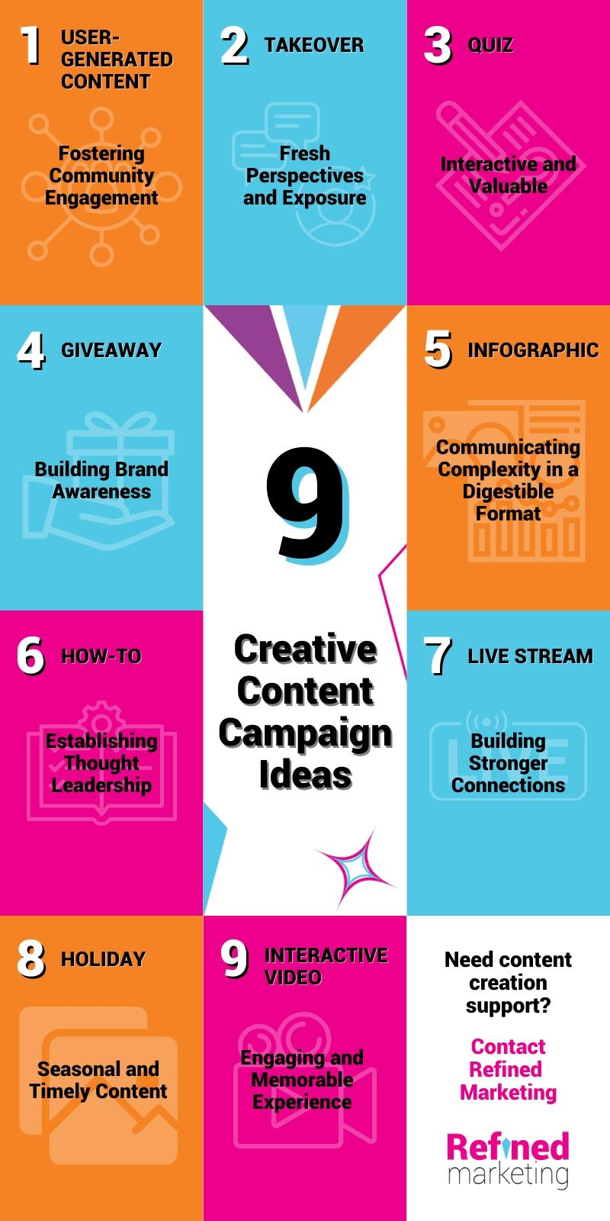**Twitter & LinkedIn: Thought leadership in wearable tech and industry trends.**

* + - 1. **Influencer & Celebrity Endorsements**

**Collaborate with tech YouTubers, fitness influencers, and Bollywood/Cricket celebrities.**

* + - 1. **Content Marketing & SEO**

**Blog posts on wearable tech trends, fitness hacks, and smartwatch comparisons.**

**SEO-optimized website with product guides and reviews.**

* + - 1. **Paid Advertising & Performance Marketing**

**Google Ads & Meta Ads: Target intent-based searches & social media interests.**

**Amazon & Flipkart Ads: Optimize for seasonal sales & new launches.**

* + 1. **E-commerce & Omnichannel Strategy**

**DTC Website Optimization: Exclusive discounts, EMI offers, and early access to new products.**

**Marketplace Presence: Maintain strong ratings and customer engagement on**

**Post Creation:-**

**Here’s a content plan tailored for Noise, focusing on engaging tech and lifestyle audiences.**

**Content Categories & Formats**

**Format 1: Educational Carousel (Instagram & LinkedIn)**

**Topic: “Smartwatch Features You’re Not Using – But Should!”**

**Post Idea: A 5-slide carousel showcasing underrated smartwatch features with visuals.**

**Example Features:**

* + 1. **Sleep Tracking & Insights**
    2. **Customizable Watch Faces**
    3. **Stress Monitoring**
    4. **Voice Assistant Shortcuts**
    5. **Find My Phone Feature**

**CTA: “Which feature do you use the most? Drop a comment!”**

**Format 2: Video (Reels, YouTube Shorts, TikTok)**

**Topic: “Can a Smartwatch Make You Healthier?”**

**Video Structure:**

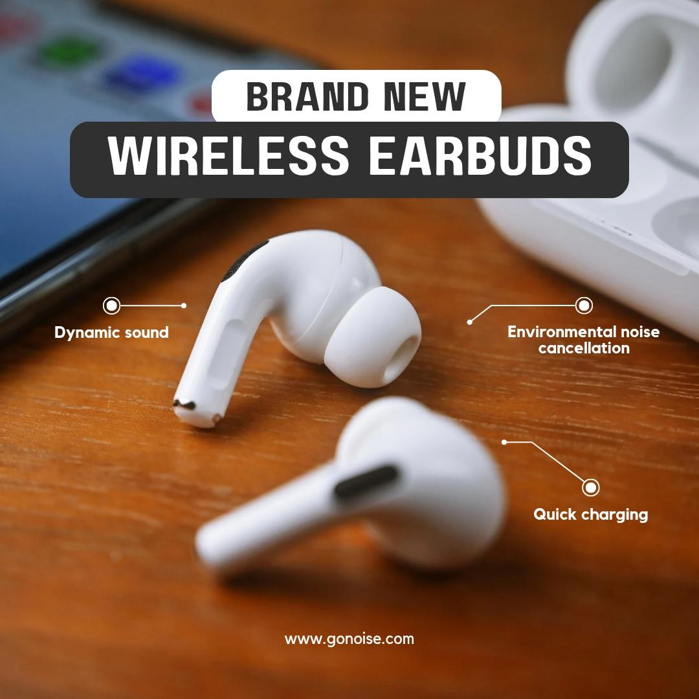**Hook: “Your smartwatch does more than just show time!”**

**Breakdown of health-tracking features (Heart Rate, SpO2, Sleep, Steps, etc.)**

**Call to Action: “Tag a friend who needs to track their health better!”**

**Trending Relevance: Wearable health tech is a hot topic, and explainer videos perform well.**

**Format 3: User-Generated Content Challenge (Instagram & Twitter/X)**

**Topic: “#NoiseLife Challenge”**

**Post Idea: Encourage users to share their smartwatch setups, custom watch faces, or how Noise products enhance their daily lives. Feature the best submissions weekly.**

**Trending Relevance: UGC builds community and brand trust.**

**Instagram Stories (3-Day Series – Saved in Highlights as ‘Noise Insider’)**

* + 1. **Day 1: Behind-the-Scenes**

**Show the making of a Noise product or an office tour.**

**Caption: “Ever wondered what goes behind creating your favorite gadgets?”**

* + 1. **Day 2: Poll/Quiz**

**Question: “What do you look for in a smartwatch?”**

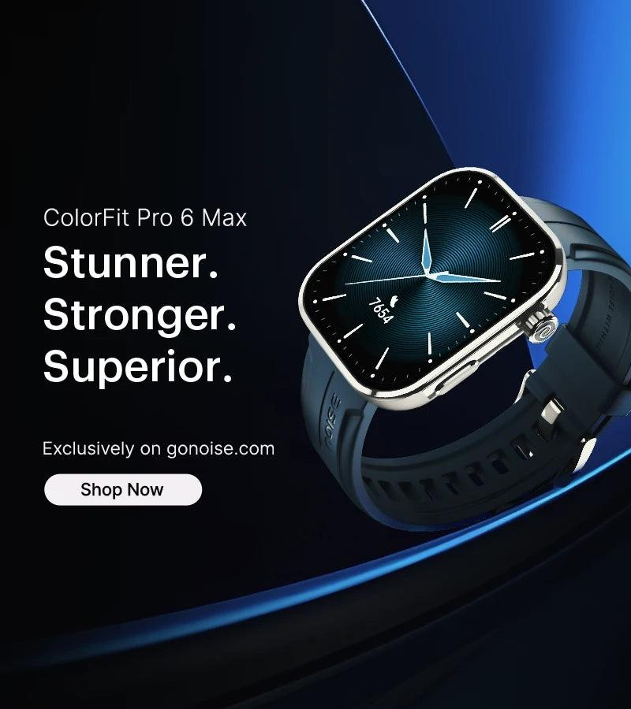**Poll options: a) Battery Life b) Fitness Features c) Design d) Smart Features**

* + 1. **Day 3: Sneak Peek**

**Tease an upcoming product launch or feature update.**

**Caption: “Something exciting is coming! Can you guess what it is?”**

**Monitoring & Optimization Strategy**

* + 1. **Track Performance Using Insights**

**Engagement: Likes, comments, shares, saves**

**Reach & impressions**

**Click-through rates on Stories**

* + 1. **Refinement Based on Data**

**If video watch time is low, improve the hook in the first 3 seconds.**

**If carousel saves are low, make the visuals more engaging with GIFs or animations.**

**If Stories get low interaction, adjust CTA placement or add interactive stickers.**

**Would you like me to tailor this further based on Noise’s current campaigns?**

**Design/vedio editing:-**

**Alright, let’s refine those design and video editing strategies specifically for the Noise brand, keeping its youthful, tech-savvy, and active lifestyle focus in mind.**

**I. Canva Design Enhancements for Noise:**

**\* Vibrant Color Palettes:**

**\* Utilize bright, energetic colors that resonate with the brand’s youthful image.**

**\* Experiment with gradient overlays and neon effects.**

**\* Ensure color consistency across all platforms.**

**\* Dynamic Typography:**

**\* Use bold, modern fonts that convey a sense of energy and innovation.**

**\* Experiment with kinetic typography and animated text.**

**\* Maintain legibility, especially on mobile devices.**

**\* Lifestyle Imagery:**

**\* Feature diverse and inclusive imagery that reflects the target audience’s lifestyle.**

**\* Showcase people using Noise products in active, social, and tech-focused settings.**

**\* Use high-quality photos and videos.**

**\* Product Mockups:**

**\* Create realistic product mockups to showcase features and design.**

**\* Use 3D renders and animations to highlight key details.**

**\* Showcase product variations and customization options.**

**\* Interactive Design:**

**\* Create interactive social media stories with polls, quizzes, and AR filters.**

**\* Design engaging infographics and data visualizations.**

**\* Design templates for user generated content, and run campaigns that encourage their use.**

**\* Consistent Brand Visuals:**

**\* Maintain a consistent visual style across all platforms.**

**\* Use brand templates for social media posts, stories, and thumbnails.**

**\* Ensure that all visuals align with the brand’s overall aesthetic.**

**II. VN Video Editing Enhancements for Noise:**

**\* Fast-Paced Edits:**

**\* Utilize quick cuts and dynamic transitions to maintain viewer engagement.**

**\* Sync video edits to the beat of the music.**

**\* Create fast-paced montages showcasing product features and lifestyle moments.**

**\* Trending Audio and Effects:**

**\* Incorporate trending audio and effects from platforms like TikTok and Instagram Reels.**

**\* Stay up-to-date with the latest video editing trends.**

**\* Use effects that enhance the video’s visual appeal and create a sense of excitement.**

**\* Mobile-First Optimization:**

**\* Optimize videos for vertical viewing on mobile devices.**

**\* Use on-screen text and graphics that are easily readable on small screens.**

**\* Keep videos short and engaging.**

**\* Product Demonstrations:**

**\* Create clear and concise product demonstrations that highlight key features.**

**\* Use close-up shots and slow-motion to emphasize details.**

**\* Add on-screen text and annotations to explain features.**

**\* User-Generated Content (UGC) Integration:**

**Social media ad campaign:**

**Noise, a connected lifestyle brand, recently launched the “Made of Noise” campaign, featuring Virat Kohli and Taapsee Pannu, emphasizing the power of both internal and external voices in shaping success. The campaign celebrates the idea that we are all made by the sounds that surround us, both positive and negative.**

**A social media ad campaign for a noise brand (such as a company selling noise-canceling headphones, soundproofing solutions, or white noise machines) should be visually striking, emotionally engaging, and focused on solving a problem—excess noise and distractions.**

**Ad Campaign Concept: “Silence, Perfected.”**

1. **Campaign Goals:**

**Increase brand awareness**

**Highlight the problem of noise pollution**

**Showcase the product’s effectiveness**

**Drive engagement and conversions**

1. **Target Audience:**

**Professionals and remote workers**

**Students and avid readers**

**Frequent travelers**

**Gamers and audiophiles**

**Parents (for baby sleep solutions)**

1. **Social Media Platforms:**

**Instagram & Facebook (visual storytelling, influencer marketing)**

**YouTube & TikTok (short demo videos, testimonials)**

**LinkedIn (targeting professionals & work-from-home audience)**

**Twitter (quick tips & discussions on noise pollution)**

1. **Ad Content Ideas:**
   1. **Video Ads: (for Instagram Reels, TikTok, YouTube Shorts)**

**“Before & After” Transformation – Show a chaotic, noisy environment (traffic, office chatter, construction) followed by total silence after using the product.**

**User Reactions – Capture real users trying the product for the first time, showing their relief and amazement.**

**“Escape the Noise” Mini-Series – Short clips of different scenarios (busy café, airport, train, office) where the product helps people focus.**

* 1. **Static & Carousel Ads: (for Instagram, Facebook, LinkedIn)**

**“Can You Hear the Silence?” – A visually striking image of a peaceful environment with a catchy tagline.**

**Side-by-Side Comparisons – Showing the difference in decibels before and after using the product.**

**Lifestyle Shots – Happy customers using the product in everyday situations (working, traveling, meditating).**

* 1. **Story Ads & Polls: (for Instagram & Facebook Stories)**

**“How often are you distracted by noise?” (Poll: Too Often | Rarely)**

**“What’s your biggest noise distraction?” (Quiz: Traffic, Loud Neighbors, Office Chatter, Others)**

**Countdown timer for product launch or flash sale.**

* 1. **Influencer & UGC (User-Generated Content):**

**Partner with influencers in productivity, wellness, and travel niches.**

**Encourage customers to share their experience with a branded hashtag (#SilencePerfected).**

* 1. **Paid Ads Call-to-Action (CTA):**

**“Experience Pure Silence – Shop Now!”**

**“Cut the Noise. Stay Focused. Try Today.”**

**“Travel Without Distractions – Limited Offer!”**

1. **Ad Budget & Strategy:**

**Retargeting Ads – Show ads to users who have visited the website but haven’t purchased.**

**Lookalike Audiences – Target new customers similar to existing ones.**

**A/B Testing – Test different creatives, headlines, and CTAs to see what performs best. * Incorporate UGC into video content to build community and authenticity.**

**\* Create compilation videos featuring user-submitted photos and videos.**

**\* Feature user testimonials and reviews.**

**\* Sound Design:**

**\* Pay close attention to sound design to create an immersive audio experience.**

**\* Use high-quality background music and sound effects.**

**\* Ensure that audio levels are balanced and consistent.**

**0 * Color Grading and Visual Effects:**

**\* Use color grading to create a consistent and visually appealing aesthetic.**

**\* Use visual effects to enhance the video’s impact and create a sense of excitement.**

**\* Ensure that effects are used tastefully and enhance the overall message.**

**\* Focus on short form video.**

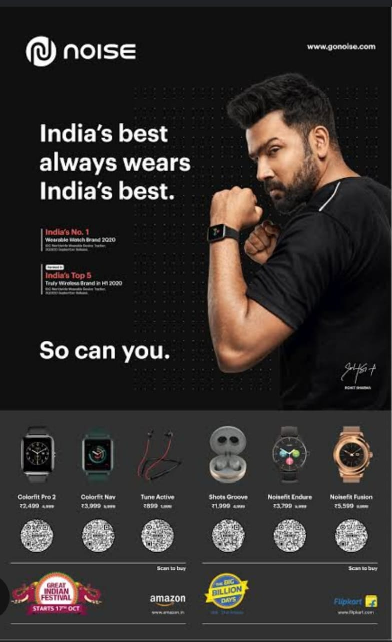 **\* Most content should be created for short form video platforms.**

**\* Use trends, and trending sounds.**

**\* Create videos that loop well.**

**III. Noise Brand Specific Video Themes:**

**\* “Unleash Your Noise”:**

**\* Videos showcasing individuals expressing their individuality and passion.**

**\* Focus on vibrant visuals, energetic music, and dynamic edits.**

**\* “Tech On-the-Go”:**

**\* Videos demonstrating how Noise products enhance active lifestyles.**

**\* Showcase fitness tracking, portable audio, and seamless connectivity.**

**\* “Sound of Style”:**

**\* Videos highlighting the design and style of Noise products.**

**\* Focus on product aesthetics, customization options, and fashion integration.**

**\* “Noise Community”:**

**\* Videos featuring user generated content, and community events.**

**\* Focus on building a strong community around the brand.**

**By implementing these refined strategies, Noise can create a strong visual identity and engaging video content that resonates with its target audience and reinforces its brand message.**

**E-mail ad campaign of noise brand**

**To create an effective email ad campaign for the Noise brand, focus on highlighting their “Made of Noise” campaign featuring Virat Kohli and Taapsee Pannu, emphasizing lifestyle and technology, and using targeted messaging to reach the right audience.**

**Here’s a breakdown of key elements:**

1. **Campaign Theme & Messaging:**

**“Made of Noise”:**

**Promote the brand’s core message of being a lifestyle brand that is “Made of Noise”.**

**Lifestyle Focus:**

**Showcase how Noise products enhance daily life, emphasizing fitness, music, and connectivity.**

**Technology Integration:**

**Highlight the innovative features and functionalities of Noise products, such as smartwatches, earbuds, and headphones.**

**Virat Kohli & Taapsee Pannu:**

**Leverage the brand ambassadors’ popularity and association with the campaign.**

**Targeted Messaging:**

**Tailor the message to different segments (e.g., fitness enthusiasts, music lovers, tech-savvy individuals).**

1. **Email Content & Structure:**

**Subject Line: Use catchy and relevant subject lines that pique interest (e.g., “Unlock Your Potential with Noise”, “Level Up Your Lifestyle with Noise", ”Experience the Power of Noise”).**

**Visuals: Use high-quality images and videos that showcase the products and campaign theme.**

**Clear Call to Action: Encourage recipients to visit the Noise website, explore products, or sign up for a promotion.**

**Personalization: Address recipients by name and tailor the content based on their past interactions or preferences.**

**Offer & Promotion: Include a special offer or promotion to incentivize purchases.**

**Brand Story: Briefly explain the brand’s mission and values.**

1. **Email List & Segmentation:**

**Target Audience: Identify the ideal customer profile (e.g., age, location, interests).**

**List Building: Collect email addresses through website forms, social media campaigns, or other channels.**

**Segmentation: Divide the email list into segments based on demographics, interests, or purchase history.**

1. **Email Marketing Platform:**

**Choose a platform: Select a reliable email marketing platform that offers features like segmentation, automation, and analytics.**

**Testing: Test the email campaign before sending it to the entire list.**

1. **Analytics & Optimization:**

**Track Key Metrics: Monitor open rates, click-through rates, conversions, and other relevant metrics.**

**Optimize for Results: Refine the email campaign based on the data collected**

**Campaign Theme: “Silence, Perfected.”**

1. **Campaign Goals:**

**✅ Build brand awareness**

**✅ Showcase product benefits**

**✅ Increase engagement & website traffic**

**✅ Boost conversions with exclusive offers**

1. **Email Sequence & Content Strategy**

**📧 Email 1: The Welcome Email (Day 1) – Subject Line: “Escape the Noise – Welcome to [Brand Name]!”**

**Warm welcome + brand mission (helping people enjoy peace & focus).**

**Quick overview of products & benefits.**

**CTA: “Discover the Power of Silence →” (link to website).**

**Optional: 10% discount for new subscribers.**

**📧 Email 2: Problem-Solution Approach (Day 3-4) – Subject Line: “Is Noise Ruining Your Focus?”**

**Discuss common noise problems (work, travel, sleep).**

**Introduce the product as the perfect solution.**

**Include a short customer testimonial or stat about noise pollution.**

**CTA: “Find Your Peace →” (link to product page).**

**📧 Email 3: Social Proof & Testimonials (Day 6-7) – Subject Line: “What People Are Saying About [Product Name]”**

**Showcase real customer reviews & ratings.**

**Before-and-after noise reduction comparison (image or video).**

**CTA: “Join Thousands of Happy Customers →”**

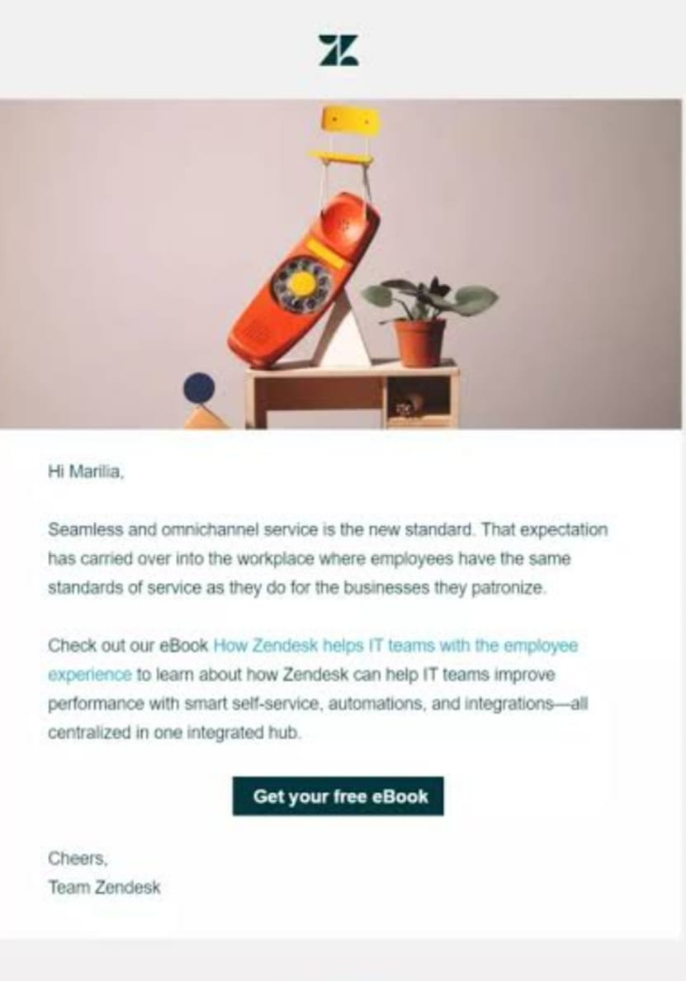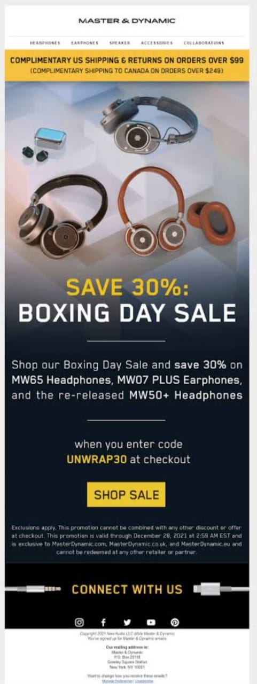

**📧 Email 4: Product Features & Benefits (Day 9-10) – Subject Line: “Why [Product Name] is a Game-Changer!”**

**Highlight unique features (e.g., Advanced Noise-Canceling Tech, Long Battery Life, Comfort).**

**Break down benefits for different users (e.g., for travelers, professionals, gamers).**

**CTA: “Try It Risk-Free →” (offer free returns or guarantee).**

**📧 Email 5: Limited-Time Offer (Day 12-14) – Subject Line: “Last Chance: 20% Off Ends Soon!”**

**Create urgency with a limited-time deal or free shipping offer.**

**Use a countdown timer GIF for extra urgency.**

**CTA: “Claim Your Peace Now →”**

**📧 Email 6: Last Reminder (Day 15-16) – Subject Line: “Only a Few Hours Left! Don’t Miss Out.”**

**One final push before the offer expires.**

**Highlight FOMO with a customer quote or bestseller status.**

**CTA: “Shop Now Before It’s Gone →”**

1. **Email Design & Best Practices**

**✅ Minimalist & Clean Layout: No clutter, easy-to-read.**

**✅ Engaging Visuals: High-quality images/videos showing the product in use.**

**✅ Compelling CTAs: Clear, action-driven buttons.**

**✅ Mobile-Optimized: 50-70% of emails are read on mobile devices.**

**✅ Personalization: Use the recipient’s name for a personal touch.**

